Merit Badge Process for Scouts Parents and Unit Leaders
Directions on how to become a merit badge counselor and training can be found here: https://scoutingcolorado.org/resources/adult-training-programs/merit-badge-counselors/

There is more to merit badges than simply providing opportunities to learn skills. There is more to them than an introduction to lifetime hobbies, or the inspiration to pursue a career—though these invaluable results occur regularly. It all begins with a Scout’s initial interest and effort in a merit badge subject, followed by a discussion with the unit leader or designated assistant, continues through meetings with a counselor, and culminates in advancement and recognition. It is an uncomplicated process that gives a Scout the confidence achieved through overcoming obstacles. Social skills improve. Self-reliance develops. Examples are set and followed. And fields of study and interest are explored beyond the limits of the school classroom.

All merit badge requirements must be met while a registered Boy Scout, or a qualified Venturer or Sea Scout. Accomplishments before joining, or while a Cub Scout, do not apply

The merit badge program is not school and should not be thought of in terms of classes, homework, worksheets, etc. In the Scouting program a Scout learns by doing.

Merit Badge Process

- The Scout develops an interest in a merit badge and may begin working on the requirements.
- The Scout discusses his interest in the merit badge with his unit leader. (note: a unit leader is a Scoutmaster or Venturing Advisor)
- The unit leader signs a blue card and provides the Scout with at least one counselor contact from the Council approved list.
- The Scout contacts the counselor.
- The counselor considers any work toward requirements completed prior to the initial discussion with the unit leader.
- The Scout, and the counselor meet (often several times).
- The Scout finishes the requirements.
- The counselor approves completion.
- The Scout returns the signed blue card to his unit leader, who signs the applicant record section of the blue card.
- The unit leader gives the Scout the applicant record.
- The unit reports the merit badge to the council via Internet Advancement
- The Scout receives his merit badge.

Scouts obtain Merit Badge Counselor recommendations and contact information from their Scoutmaster or Venturing Advisor. The council office will not hand out Merit Badge Counselor lists to units, Scouts or parents. Parents and Scouts should not try to obtain merit badge counselor recommendations outside this process.
A few merit badges have certain restrictions, but otherwise any registered Boy Scout, or qualified Venturer or Sea Scout may work on any of them at any time. Before the Scout begins working with a merit badge counselor, however, the Scout is to have a discussion with his unit leader. That a discussion has been held is indicated by the unit leader’s signature on the Application for Merit Badge, No. 34124, commonly called the “blue card.” It is expected that the unit leader (e.g., Scoutmaster) do some due diligence in the selection of a merit badge counselor to recommend. Something more than simply selecting a name off a list of registered merit badge counselors. Although it is the unit leader’s responsibility to see that at least one merit badge counselor is identified from those approved and made available, the Scout may have one in mind with whom he would like to work. The unit leader and Scout should come to agreement as to who the counselor will be. Lacking agreement, the Scout must be allowed to work with the counselor of his choice, so long as the counselor is registered and has been approved by the council advancement committee.

The intent of the process is to make sure the Scout is interacting with his Scoutmaster for the recommendation of a counselor and that the Scoutmaster is aware of the advancement of their Scouts.

Scoutmasters can obtain a list of local Merit Badge Counselors through their District Advancement Chairman (or their designee.) The list is also available to unit leaders in Scoutbook. If the District Advancement Chairman is unavailable; Scoutmasters should go to the District Committee Chairman for assistance.

Questions, recommendation of a merit badge counselor, and issues are handled as follows:
- Scouts and parents should go to their Scoutmaster, Venturing Advisor or Sea Scout Skipper (i.e., unit leaders)
- Unit leaders should go to their District Advancement Chairman (or designee)

This process is to be in compliance with National policy as outlined in the Guide to Advancement section 7.0.2.3 No one should be obtaining merit badge counselor lists outside of this process.

Earning merit badges should be Scout initiated, Scout researched, and Scout learned.

It is not the responsibility of leaders or parents to provide merit badge classes for Scouts to achieve merit badges. Instead, the Scout should be researching merit badge requirements, learning what they can on their own and approaching recommended merit badge counselors to be tested on what they have learned. Merit badge counselors are mentors, coaches and advisors in the process.

The Merit Badge Process is setup the way it is to teach the Scout to be self-directed. Remember: our goal here is not to get the Scout to Eagle as fast as possible, but character development, citizenship training, and personal fitness.

Ideally, merit badges are an individual learning experience with guided learning and some skill training by merit badge counselors; rather than something that is learned in a classroom full of other Scouts.

The merit badge experience should be hands-on and interactive, and should not be modeled after a typical school setting. Instead, it is meant to be an active program so enticing to young men that they will want to take responsibility for their own full participation.

Counselors are free to choose the setting they use to counsel the Scouts as long as they follow the BSA Youth Protection Guidelines. If subject matter relates to a counselor’s vocation, meetings with youth might take place at an office or work site. Hobby-related badges are usually counseled at home. For others like Rowing, Rifle Shooting, or Geocaching, learning could occur in the field where special facilities or an appropriate venue are available.

Once a counselor has reviewed the Scoutmaster signed Application for Merit Badge (blue card), he or she might begin with discussions about what the Scout already knows. This could be followed with coaching, guidance, and additional meetings, not only for passing the candidate on the requirements, but also to help him understand the subject. The sort of hands-on interactive experience described here, with personal coaching and guidance, is hardly ever achieved in any setting except when one counselor works directly with one Scout and his buddy, or with a very small group. Thus, this small-scale approach is the recommended best practice for merit badge instruction and requirement fulfillment.

Units, districts, and councils should focus on providing the most direct merit badge experiences possible. Large group and Web-based instruction, while perhaps efficient, do not measure up in terms of the desired outcomes with regard to learning and positive association with adults.

See section 7.0.3.0 of the Guide to Advancement, this gives you our recommended best practices. The intent is for the Scout to meet face to face (following YPT policies) with a counselor (adult association.)
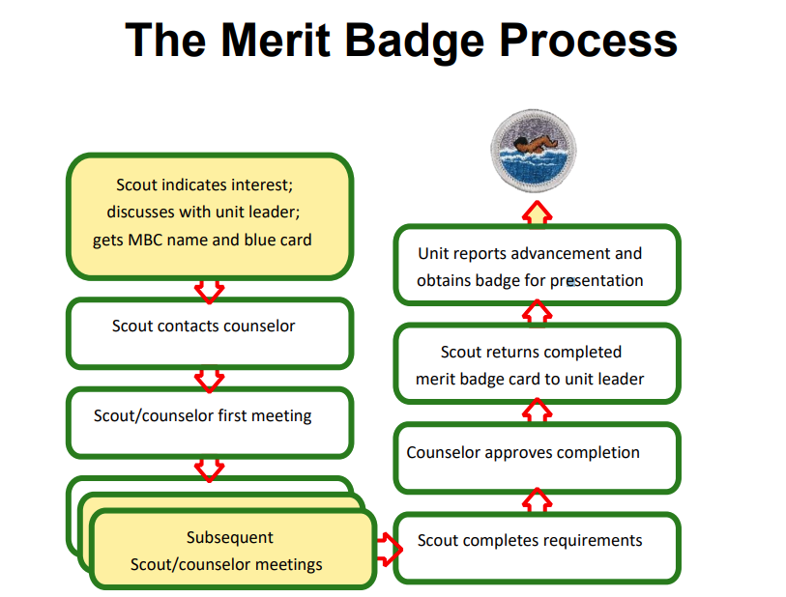

Merit Badge Frequently Asked Questions

Q. Do you need to be 15 years old with a First Class Scout rank to begin working on merit badges?
A. No, you can be younger. Registered Scouts can work on merit badges whatever the rank. All merit badge requirements must be met while a registered Boy Scout, or a qualified Venturer or Sea Scout. Accomplishments before joining, or while a Cub Scout, do not apply.

Q. Is it true counselors can’t be approved to counsel more than five merit badges?
A. The Greater Colorado Council policy is that a counselor can sign up to council up to 15 merit badges. However, we do want the counselor to be very familiar with the subject area of each and every badge they counsel.

Q. Is there a limit to the number of badges a Scout may earn from one counselor?
A. The only limit imposed by the Greater Colorado Council is the number of badges the counselor is approved to counsel. In situations where a Scout is earning a large number of badges from just one counselor, the unit leader is permitted to place a limit on the number of merit badges that may be earned from one counselor, as long as the same limit applies to all Scouts in the unit.

Q. Can a parent counsel their own son?
A. Approved counselors may work with and pass any member, including their own son, ward, or relative. Nevertheless, we often teach young people the importance of broadening horizons. Scouts meeting with counselors beyond their families and beyond even their own units are doing that. They will benefit from the perspectives of many “teachers” and will learn more as a result. They should be encouraged to reach out.

Q. Can we make filling out a “merit badge worksheet” as found on the Internet at sites such as meritbage.org mandatory for completing a badge?
A. Worksheets and other materials that may be of assistance in earning merit badges are available from a variety of places including unofficial sources on the internet and even troop libraries. Use of these aids is permissible as long as the materials can be correlated with the current requirements that Scouts must fulfill. Completing “worksheets” may suffice where a requirement calls for something in writing, but this would not work for a requirement where the Scout must discuss, tell, show, or demonstrate, etc. Note that Scouts shall not be required to use these learning aids in order to complete a merit badge.

Q. Is it true that if a Scout is working on too many merit badges, a Scoutmaster is allowed to reject a request to do another?
A. Not true. A Scout may work on as many as they want. However, a Scoutmaster can advise a Scout not to, remembering that it is the Scout’s choice, not the Scoutmaster’s, to start another badge. Keep in mind that one of the purposes of the merit badge program is to expose a Scout to many vocations and advocations. It could very well be the case that the Scout does not find one or more of these not to their liking after they look into the area. This is part of the program and a leader should not force a Scout to finish a badge before starting another.

Q. If we know that a Scout has gone to an unregistered merit badge counselor, can we force the Scout to redo the merit badge with a properly registered counselor?
A. A Scout who has earned a merit badge from a registered and approved counselor by actually and personally fulfilling the requirements as written will have met the purpose of the merit badge program and the contribution to the aims of Scouting. The badge is his to keep and count toward his advancement. The same holds true if a Scout, without intent to violate national BSA procedures or policies, fulfills merit badge requirements with someone who is not registered and approved as a counselor. This could happen, for example, if a Scout, in good faith, contacts someone who has inadvertently been dropped from a unit or district charter or otherwise has an expired membership, but who remains on an approved list of counselors. In cases where it is discovered that unregistered or unapproved individuals are signing off merit badges, this should be reported to the council or district advancement committee so they have the opportunity to follow up. But it is also the responsibility of unit leaders to help Scouts understand that only registered and approved counselors are to be used. Because background checks, Youth Protection training, and merit badge program quality control are involved, BSA registration and council advancement committee approval are mandated procedures. If a Scout to whom this mandated procedure has been made clear has ignored it, then unit leaders may require the youth to work with other counselors who are properly documented who will verify that requirements were met and sign the blue cards. A unit leader should discuss any potential follow-up counselors with the Scout and provide the name of at least one, but Scouts must be allowed to work with registered and approved counselors of their choice.

Q. Is double dipping allowed? If you use an activity for one badge, can you use it for another.
A. You may use an activity for multiple badges, but the activity must meet the exact requirements as listed in both requirements. Be careful, several requirements sound the same at first read, but at a closer read are different.

Q. Does a Scout always need to get a Scoutmaster signature on a blue card prior to working on a badge? A. The Scout may want to take advantage of opportunities at merit badge fairs or midways, or at rock-climbing gyms or whitewater rafting trips that provide merit badge instruction. This is acceptable, but the Scout must still discuss the merit badge with the unit leader and get a signed blue card as soon as possible. Should a Scout want to change counselors, they should once again speak with the unit leader to verify that the counselor is properly registered and approved. Whatever the source, all merit badge counselors must be registered and approved for the merit badges they counsel.

Q: Is it true the ideal merit badge group or class is rather large?
A. The ‘Guide to Advancement’ discourages large group settings. Small groups allow for one on one attention.

Q. Is it true that you need to earn all the required merit badges before earning elective badges?
A. No. A registered Scout can work on any badge they choose, when they choose.

Q. What to Do When Requirements Change?
A. Once a Scout begins work, they may continue using the requirements they started with until completion of the badge. Alternatively, they may choose to switch to the revised requirements. Sometimes, however—especially for more significant changes—the Boy Scout Handbook, the Boy Scout Requirements book, www.scouting.org/meritbadges, or official communications from the National Council may set forth a different procedure that must be used and may establish a date by when use of the old requirements must cease.

Q. Do partials expire?
A. There is no time limit between starting and completing a badge, although a counselor may determine so much time has passed since any effort took place that the new requirements must be used.

Q. Does a unit have to accept all signed blue cards presented to them?
A. Yes, except in two cases. The first case was answered in the question about “If we know that Scout has gone to an unregistered merit badge counselor…”

The second case is the following:

From time to time, it may be discovered that merit badges could not actually have been earned. For example, a Scout who returns from summer camp or a merit badge fair with signed blue cards for an extraordinary number of badges could raise concerns. If, after consulting with those involved in the merit badge program—such as an event coordinator, the camp director, or a merit badge counselor—it becomes plainly evident that a youth could not have actually and personally fulfilled requirements as written, then the limited recourse outlined below is available. It may result in a decision that some or all of the requirements for a badge could not have been fulfilled, and thus, that the badge was not actually earned.

After such a consultation, the unit leader, in a positive environment similar to that of a unit leader conference, discusses with the Scout the circumstances under which a merit badge in question was approved. A parent or an assistant unit leader should attend as an observer. The young person shall not be retested on the requirements, but a conversation with him can reveal if he was present at the class and actually and personally fulfilled all the requirements. Such a discussion could cover who taught a class, what sort of activities took place, where and when they occurred, how testing was done, what the Scout might have brought home from the class, and other similar process-oriented details.

In most cases, with a fair and friendly approach, a young person who did not complete the requirements will admit it. Short of this, however, if it remains clear under the circumstances that some or all of the requirements could not have been met, then the merit badge is not reported or awarded, and does not count toward advancement. The unit leader then offers the name of at least one other merit badge counselor through whom any incomplete requirements may be finished. Note that in this case a merit badge is not “taken away” because, although signed off, it was never actually earned.

Just as we avoid penalizing Scouts for the mistakes of adults, it should be a rare occurrence that a unit leader finds the need to question whether merit badges have been earned. This procedure for recourse is limited and reserved only for clear and evident cases of noncompletion or nonparticipation. For example, the recourse could be allowed when it would not have been possible to complete a specific requirement at the location of the class, event, or camp; if time available was not sufficient—perhaps due to class size or other factors—for the counselor to observe that each Scout personally and actually completed all the requirements; if time available was insufficient for a “calendar” requirement such as for Personal Fitness or Personal Management; or if multiple merit badges in question were scheduled at the same time.

This procedure is not to be viewed as an opportunity for retesting on requirements, for interjecting another set of standards over those of a merit badge counselor, or for debating issues such as whether a Scout was strong enough, mature enough, or old enough to have completed requirements.

Unit leaders who find it necessary to make use of this recourse must act quickly—if possible, within 30 days of discovery. It is inappropriate to delay a Scout’s advancement with anything less than a prompt decision.

Q. Does the Scout have any recourse if they feel they were treated unfairly by the unit?
A. If a Scout or their parent or guardian believes a unit leader has incorrectly determined a Scout has not earned a merit badge, or more than 30 days have passed without a reasonable explanation for the lack of a decision, they should address their concerns with the unit committee. They should first, however, develop a thorough understanding of the merit badge requirements and that each one must be passed exactly as it is set forth. Upon encountering any merit badge program where BSA standards are not upheld, unit leaders are strongly encouraged to report the incident to the council advancement committee,

Q. Do we need two registered leaders for consulting sessions like meeting with Scouts as a Merit Badge Counselor or Project Approver?
A. Either two registered leaders over 21 or if the merit badge counselor or project approver is registered and over 21 years of age, a parent may substitute for the second registered adult. Two registered leaders over the age of 21 must be present at merit badge group sessions.

Reference: Chapter 7 of the Guide to Advancement

